

SESI 2020/2021 SEMESTER 1
SCSV3213 – SECTION 2
FUNDAMENTAL OF IMAGE PROCESSING
Lecturer: Dr. Md. Sah bin Hj. Salam

ASSIGNMENT 4
Document Scanner

Team members:

Simon Chong Kai Yuen (A19EC3028)
Clive Lai Yi Cheng (A19EC3019)
Ng Shu Yu (A19EC3031)

Pipeline Process
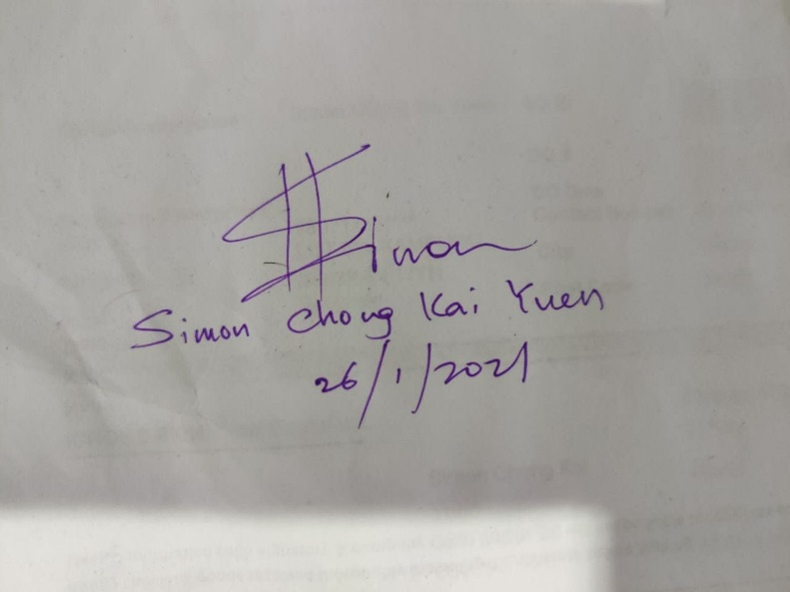
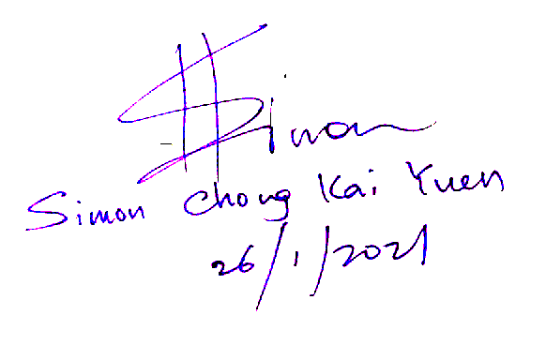
my_image = imread(pickedimage);
my_image = my_image(:,:,:);
processed_img = my_image;
processed_img(my_image>=value1)=255;
processed_img(my_image<value1)=0;
imshow(processed_img,[]), title('Processed result')

Threshold value = 100
Output image
Input image
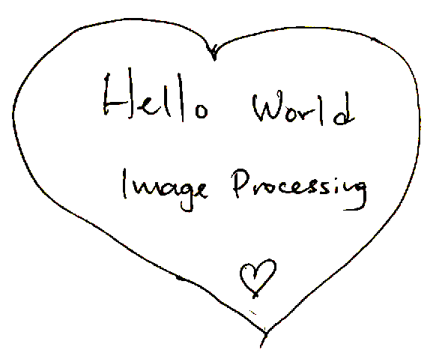
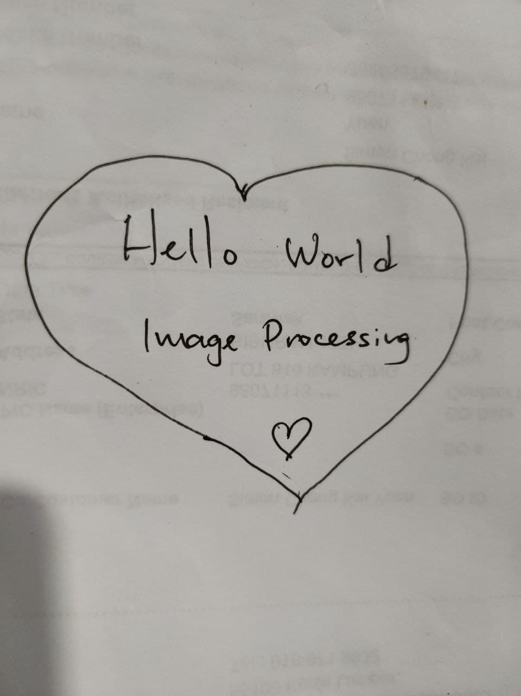
Threshold value = 90
Output image
Input image
my_image = imread(pickedimage);
my_image = my_image(:,:,:);
processed_img = my_image;
processed_img(my_image>=value1)=255;
processed_img(my_image<value1)=0;
imshow(processed_img,[]), title('Processed result')

User Manual
1.
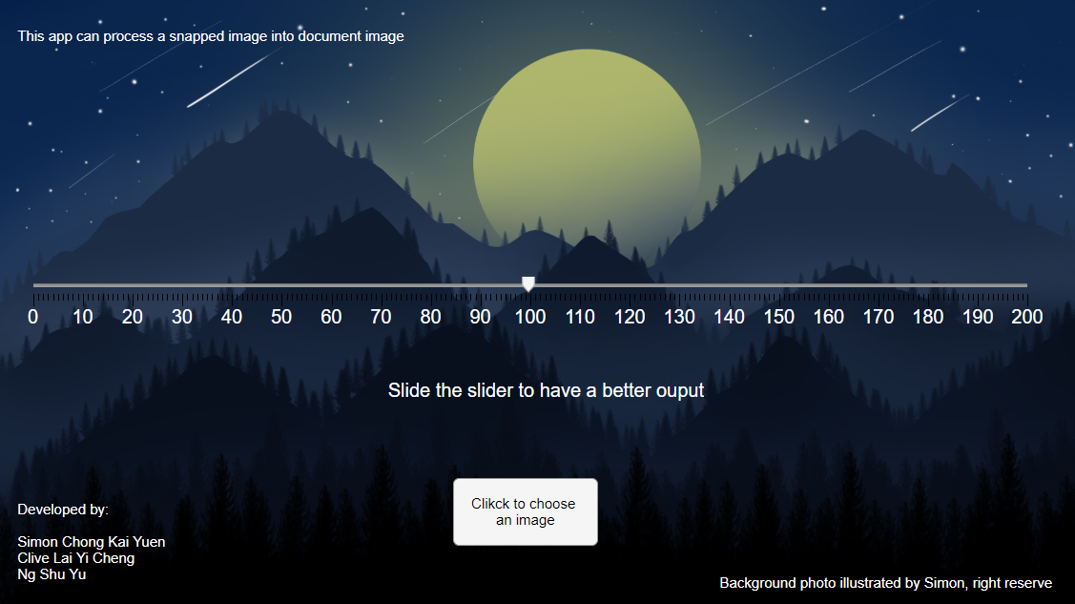
1
2
Press this button to choose a image from local storage
Select a suitable value to your image, adjust it based on the result

2.
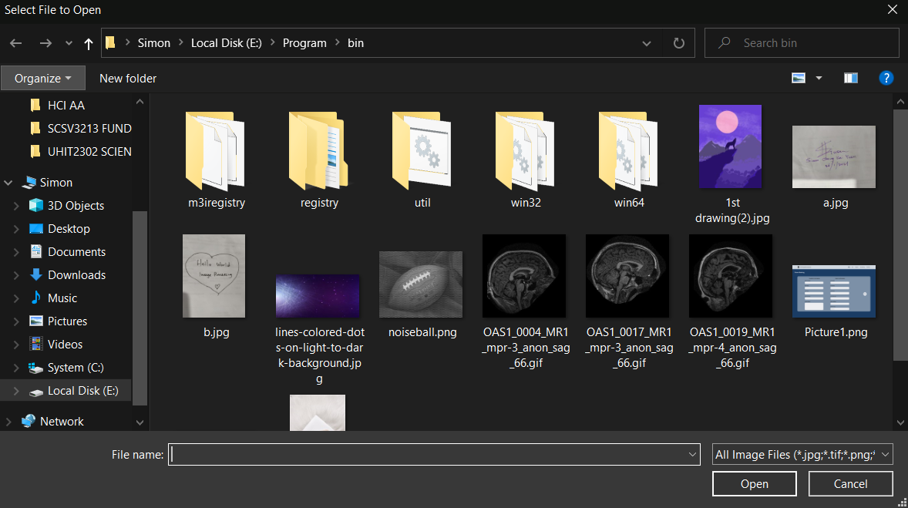
4
Click on open
Select an image that you want to process
3

3. Then you will get a processed image and you may press save button to save it
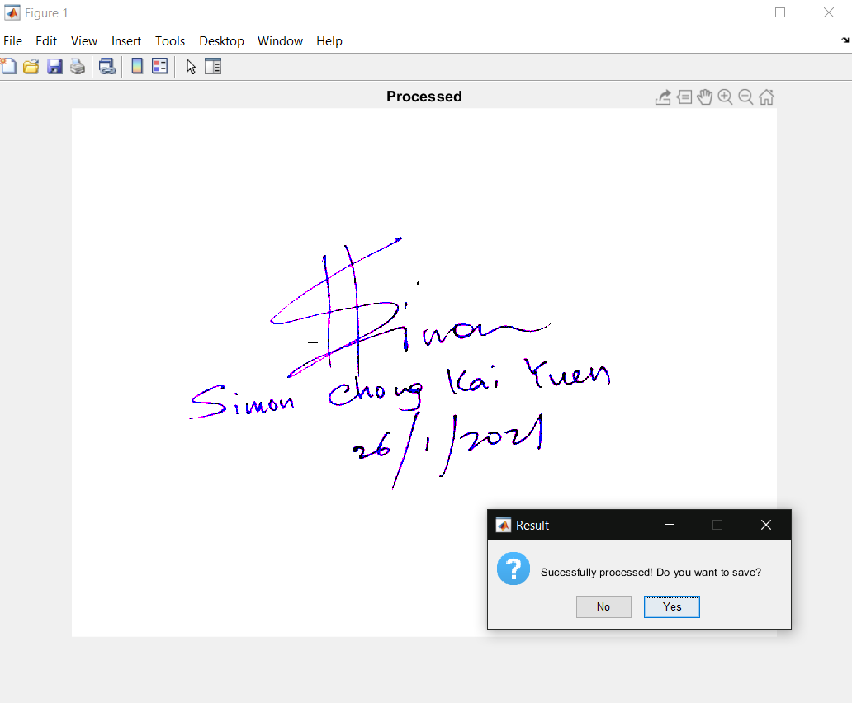

To watch a demonstraction video, please click this link
https://youtu.be/8HPntxU0UkA

Script
classdef Simon_IP_Project < matlab.apps.AppBase

% Properties that correspond to app components
properties (Access = public)
UIFigure matlab.ui.Figure
Image matlab.ui.control.Image
ClikcktochooseanimageButton matlab.ui.control.Button
SlidetheslidertohaveabetterouputSliderLabel matlab.ui.control.Label
SlidetheslidertohaveabetterouputSlider matlab.ui.control.Slider
DevelopedbySimonChongKaiYuenCliveLaiYiChengNgShuYuLabel matlab.ui.control.Label
ThisappcanprocessasnappedimageintodocumentimageLabel matlab.ui.control.Label
BackgroundphotoillustratedbySimonrightreserveLabel matlab.ui.control.Label
end

methods (Access = private)
function updateimage(app,pickedimage)
value1 = app.SlidetheslidertohaveabetterouputSlider.Value; %input treshold value by user
my_image = imread(pickedimage);
my_image = my_image(:,:,:);
processed_img = my_image;
processed_img(my_image>=value1) = 255;
processed_img(my_image<value1) = 0;
imshow(processed_img,[]), title('Processed result') %If you specify an empty matrix ([]),
% then imshow uses a display range of [min(I(:)) max(I(:))].
% In other words, the minimum value in I is black, and the maximum value is white.
promptMessage = sprintf('Sucessfully processed! Do you want to save?');
button = questdlg(promptMessage, 'Result', 'No', 'Yes', 'Yes');
if strcmpi(button, 'Yes')
imsave();
Algorithm of the image processing
end
end

end

% Callbacks that handle component events
methods (Access = private)

% Button pushed function: ClikcktochooseanimageButton
function ClikcktochooseanimageButtonPushed(app, event)
% Display uigetfile dialog
filterspec = {'*.jpg;*.tif;*.png;*.gif','All Image Files'};
[f, p] = uigetfile(filterspec);

% Make sure user didn't cancel uigetfile dialog
if (ischar(p))
fname = [p f];
updateimage(app, fname);
Let user to choose an image from local storage
end
end
end

% Component initialization
methods (Access = private)

% Create UIFigure and components
function createComponents(app)

% Create UIFigure and hide until all components are created
app.UIFigure = uifigure('Visible', 'off');
app.UIFigure.Position = [100 100 906 512];
app.UIFigure.Name = 'UI Figure';

% Create Image
app.Image = uiimage(app.UIFigure);
app.Image.Position = [-52 1 1015 512];
app.Image.ImageSource = 'star.jpg';

% Create ClikcktochooseanimageButton
app.ClikcktochooseanimageButton = uibutton(app.UIFigure, 'push');
app.ClikcktochooseanimageButton.ButtonPushedFcn = createCallbackFcn(app, @ClikcktochooseanimageButtonPushed, true);
app.ClikcktochooseanimageButton.IconAlignment = 'center';
app.ClikcktochooseanimageButton.Position = [383 53 122 57];
app.ClikcktochooseanimageButton.Text = {'Clikck to choose '; 'an image'};

% Create SlidetheslidertohaveabetterouputSliderLabel
app.SlidetheslidertohaveabetterouputSliderLabel = uilabel(app.UIFigure);
app.SlidetheslidertohaveabetterouputSliderLabel.HorizontalAlignment = 'right';
app.SlidetheslidertohaveabetterouputSliderLabel.FontSize = 16;
app.SlidetheslidertohaveabetterouputSliderLabel.FontColor = [1 1 1];
app.SlidetheslidertohaveabetterouputSliderLabel.Position = [321 172 273 22];
app.SlidetheslidertohaveabetterouputSliderLabel.Text = 'Slide the slider to have a better ouput';

% Create SlidetheslidertohaveabetterouputSlider
app.SlidetheslidertohaveabetterouputSlider = uislider(app.UIFigure);
app.SlidetheslidertohaveabetterouputSlider.Limits = [0 200];
app.SlidetheslidertohaveabetterouputSlider.MajorTicks = [0 10 20 30 40 50 60 70 80 90 100 110 120 130 140 150 160 170 180 190 200];
app.SlidetheslidertohaveabetterouputSlider.FontSize = 16;
app.SlidetheslidertohaveabetterouputSlider.FontColor = [1 1 1];
app.SlidetheslidertohaveabetterouputSlider.Position = [31 270 834 3];

% Create DevelopedbySimonChongKaiYuenCliveLaiYiChengNgShuYuLabel
app.DevelopedbySimonChongKaiYuenCliveLaiYiChengNgShuYuLabel = uilabel(app.UIFigure);
app.DevelopedbySimonChongKaiYuenCliveLaiYiChengNgShuYuLabel.FontColor = [1 1 1];
app.DevelopedbySimonChongKaiYuenCliveLaiYiChengNgShuYuLabel.Position = [18 22 129 69];
app.DevelopedbySimonChongKaiYuenCliveLaiYiChengNgShuYuLabel.Text = {'Developed by:'; ''; 'Simon Chong Kai Yuen'; 'Clive Lai Yi Cheng'; 'Ng Shu Yu'};

% Create ThisappcanprocessasnappedimageintodocumentimageLabel
app.ThisappcanprocessasnappedimageintodocumentimageLabel = uilabel(app.UIFigure);
app.ThisappcanprocessasnappedimageintodocumentimageLabel.FontColor = [1 1 1];
app.ThisappcanprocessasnappedimageintodocumentimageLabel.Position = [18 470 334 22];
app.ThisappcanprocessasnappedimageintodocumentimageLabel.Text = 'This app can process a snapped image into document image';

% Create BackgroundphotoillustratedbySimonrightreserveLabel
app.BackgroundphotoillustratedbySimonrightreserveLabel = uilabel(app.UIFigure);
app.BackgroundphotoillustratedbySimonrightreserveLabel.FontColor = [1 1 1];
app.BackgroundphotoillustratedbySimonrightreserveLabel.Position = [607 12 287 22];
app.BackgroundphotoillustratedbySimonrightreserveLabel.Text = 'Background photo illustrated by Simon, right reserve';

% Show the figure after all components are created
app.UIFigure.Visible = 'on';
end
end

% App creation and deletion
methods (Access = public)

% Construct app
function app = Simon_IP_Project

% Create UIFigure and components
createComponents(app)

% Register the app with App Designer
registerApp(app, app.UIFigure)

if nargout == 0
clear app
end
end

% Code that executes before app deletion
function delete(app)

% Delete UIFigure when app is deleted
delete(app.UIFigure)
end
end
end

